Saint Louis University

Capstone Final Project Report

Caregiving for Individuals with Dementia:

Racial and Ethnic Differences in Caregiver Health Outcomes

Submitted by:

Mohammad Reza Moslehikhah

Prabhu chaitanya molabanti

Akhil Thangallapelli

Connor Sotelo

Capstone Experience

HDS 5960-01

July 29th 2024

**1 Introduction**

**1.1 Background**

In 2024, nearly 7 million Americans are living with Alzheimer’s disease, affecting over 10.9% of the population aged 65 and older¹. By 2050, the number of people affected by this disease in the U.S. is expected to grow to nearly 13 million¹. The impact of dementia extends beyond those directly affected, deeply influencing primary caregivers who assist with daily activities ranging from basic self-care to complex tasks like financial management and community involvement2.

Caregiving for individuals with dementia is linked to significant emotional and physical stress. Research indicates that the health of caregivers is crucial for their own sustainability and quality of life3. Caregivers often experience a range of stressors that can negatively impact their physical, emotional, and social well-being3. Despite the recognition of these challenges, previous care models for dementia patients have primarily focused on the biopsychosocial principles of the patient and caregiver, often neglecting the influence of the family system and existing social relationships as determinants of health4.

Existing literature on the health of dementia caregivers frequently overlooks the role of racial and ethnic minority identity. This gap in research is significant because caregivers from minority backgrounds may face additional challenges due to the disadvantages that they face, which can exacerbate the stress and burden associated with caregiving. Understanding these disparities is essential for developing interventions that are sensitive to the unique needs of minority caregivers.

The primary goals of this study are to predict the differences in emotional, physical, and social health outcomes of caregivers based on their self-described race/ethnicity and to identify the differential factors that contribute to care-partner health compared to those who self-identify as non-Hispanic white. By leveraging data from the National Survey of Older Americans Act Participants (NSOAAP) from the years 2021 and 2022, this research aims to provide a comprehensive analysis of the health disparities among caregivers of individuals with dementia.

**2 Methods**

**2.1 Data Source and Sampling**

The study utilizes the National Survey of Older Americans Act Participants (NSOAAP) conducted by the Administration on Aging (AoA) under the Administration for Community Living (ACL). This national sample survey focuses on aging programs funded by Title III of the Older Americans Act, aiming to provide the Administration for Community Living with data collection methods for programs serving Americans aged 60 and older, as well as caregivers aged 18 and older5. The datasets acquired include multiple sets of codebooks and survey response data. Specifically within this data, there is a dataset containing caregivers’ survey responses from 2021–2022, thus offering cross-sectional survey data collected from caregivers of individuals with differing conditions. Our retrospective cohort study is defined as being a care partner to a care recipient with a diagnosed case of dementia, with a selection criterion based on the availability of race/ethnicity data. Below is a table specifying each variable used in the study.

**2.2 Details of the Dataset**

Table 1 below provides a concise summary of each variable used within the project. Included in the following columns are the variable name, the variable description which includes the original responses with numerical encodings, and finally the datatype and measurement type that would be used in the project.

| **Table 1** | | |
| --- | --- | --- |
| **Variable Name** | **Description** | **Measurement Type** |
| CGPFDSO | Has a doctor ever told you that the care recipient has Alzheimer's or dementia? -8 = Don't Know, -7 = Refused, 1 = Yes, 2 = No, 3 = Does Not Apply | Nominal |
| RACE_ETHNICITY4CAT | Constructed 4-category race/ethnicity variable -1 = Not Collected, 1 = Hispanic, 2 = White, non-Hispanic, 3 = Black, non-Hispanic, 4 = Other, including more than one race, non-Hispanic | Nominal (EXPOSURE) |
| CGHEALTH | Compared to one year ago, how would you rate your health in general now? -8 = Don't Know, 1 = Excellent, 2 = Very Good, 3 = Good, 4 = Fair, 5 = Poor | Ordinal (OUTCOME – COMPONENT) |
| CGCRHL | In general, how would you say the care recipient's health is? -8 = Don't Know, -7 = Refused, 1 = Excellent, 2 = Very Good, 3 = Good, 4 = Fair, 5 = Poor | Ordinal (COVARIATE) |
| SIUCLA1 | How often do you feel that you lack companionship? -8 = Don't Know, -7 = Refused, 1 = Hardly ever, 2 = Some of the time, 3 = Often | Ordinal (OUTCOME – SUBCOMPONENT) |
| SIUCLA2 | How often do you feel left out? -8 = Don't Know, -7 = Refused, 1 = Hardly ever, 2 = Some of the time, 3 = Often | Ordinal (OUTCOME – SUBCOMPONENT) |
| SIUCLA3 | How often do you feel isolated from others? -8 = Don't Know, -7 = Refused, 1 = Never, 2 = Hardly ever, 3 = Some of the time, 4 = Often | Ordinal (OUTCOME – SUBCOMPONENT) |
| CGFAMILY | How often does caregiving prevent you from having enough time for your family? -8 = Don't Know, -7 = Refused, 1 = Always, 2 = Usually, 3 = Sometimes, 4 = Rarely, 5 = Never | Ordinal (OUTCOME – COMPONENT) |
| CGSOCIAL | How often does caregiving conflict with your social life? -8 = Don't Know, -7 = Refused, 1 = Always, 2 = Usually, 3 = Sometimes, 4 = Rarely, 5 = Never | Ordinal (OUTCOME – COMPONENT) |
| CGFEELA | How much of the time during the past four weeks have you felt calm and peaceful? -8 = Don't Know, -7 = Refused, 1 = All of the time, 2 = Most of the time, 3 = Some of the time, 4 = A little of the time, 5 = None of the time | Ordinal (OUTCOME – SUBCOMPONENT) |
| CGFEELB | How much of the time during the past four weeks have you had a lot of energy? -8 = Don't Know, -7 = Refused, 1 = All of the time, 2 = Most of the time, 3 = Some of the time, 4 = A little of the time, 5 = None of the time | Ordinal (OUTCOME – SUBCOMPONENT) |
| CGFEELC | How much of the time during the past four weeks have you felt downhearted and depressed? -8 = Don't Know, -7 = Refused, 1 = All of the time, 2 = Most of the time, 3 = Some of the time, 4 = A little of the time, 5 = None of the time | Ordinal (OUTCOME – SUBCOMPONENT) |
| CGFINCLI | As a result of caregiving-related changes in your employment or expenses, have you had to quit your job? -8 = Don't Know, -7 = Refused, 1 = Yes, 2 = No | Nominal (COVARIATE) |
| RGENDER | What is the care recipient's sex? . = Missing, 1 = Male, 2 = Female | Nominal (COVARIATE) |
| CGPAGE | Care recipient's age group. = Missing, 4 = 60-64 Years, 5 = 65-74 Years, 6 = 75-84 Years, 7 = 85+ Years | Ordinal (COVARIATE) |
| CGENDER | What is your (caregiver's) sex? . = Missing, 1 = Male, 2 = Female | Nominal (COVARIATE) |
| AGEC | Caregiver's age group. = Missing, 2 = 18-34 Years, 3 = 35-59 Years, 4 = 60-64 Years, 5 = 65-74 Years, 6 = 75-84 Years, 7 = 85+ Years | Ordinal (COVARIATE) |
| MARITAL_STATUS | What is your marital status? 1 = Yes, 2 = No | Nominal (COVARIATE) |
| DEEDUC | What is your highest level of education? -8 = Don't Know, -7 = Refused, 1 = Less Than High School Diploma, 2 = High School Diploma Or GED, 3 = Some College (Business/Vocational/Technical), 4 = Bachelor's Degree, 5 = Some Post-Graduate Work/Advanced Degree | Ordinal (COVARIATE) |
| MSA2 | Urban/rural location -9 = Invalid Zip Code, Or Foreign Zip Code, 0 = Not In MSA, 1 = MSA, Non-Center City, 2 = MSA, Center City | Nominal (COVARIATE) |
| CAREMP | Are you currently employed? -8 = Don't Know, -7 = Refused, 1 = Yes, 2 = No | Nominal (COVARIATE) |
| DEINAB | Thinking about the total combined income from all sources for all persons in this household, was your total household annual income above or below $20,000? -8 = Don't Know, -7 = Refused, 1 = Below $20,000 [1666 Per Month Or Less], 2 = Above $20,000 [1667 Per Month Or More] | Ordinal (COVARIATE) |
| CGREL_RECODED | What is your relationship to the care recipient? 1 = Husband, 2 = Wife, 3 = Son, 4 = Son-In-Law, 5 = Daughter, 6 = Daughter-In-Law, 8 = Mother, 9 = Brother, 10 = Sister, 11 = Granddaughter, 12 = Grandson, 13 = Niece, 14 = Nephew, 15 = A Friend/Neighbor/Another Person, 91 = Other Relative | Nominal (COVARIATE) |
| CGPORT | Thinking about all the family members or friends who provide help, care, or supervision for the care recipient, what proportion of the care do you provide during a typical week? -8 = Don't Know, -7 = Refused, 1 = Less than one-quarter, 2 = About one-quarter, 3 = About half, 4 = About three-quarters, 5 = All or almost all of the care | Ordinal (COVARIATE) |
| CGNHBTR | In the past six months, have you felt that the care recipient would be better off in a nursing home, boarding home, or assisted living facility? -8 = Don't Know, -7 = Refused, 1 = Yes, 2 = No | Nominal (COVARIATE) |
| CGBASIS | Are you responsible for providing help or supervision to the care recipient on a 24-hour basis? -8 = Don't Know, -7 = Refused, 1 = Yes, 2 = No | Nominal (COVARIATE) |
| CGINSTY | On a scale from 1 to 5 where 1 is not very intense and 5 is very intense, how intense is the care you provide? -8 = Don't Know, -7 = Refused, -1 = Not Collected, 1 = Not very intense, 2 = Not intense, 3 = Neutral, 4 = Intense, 5 = Very intense | Ordinal (COVARIATE) |
| CGSATISA | How much satisfaction do you gain from performing your care tasks? -8 = Don't Know, -7 = Refused, 1 = No satisfaction, 2 = Some satisfaction, 3 = A lot of satisfaction | Ordinal (COVARIATE) |
| CGJOY | How often does being a caregiver for the person you care for give you the joy of spending time with someone you care about? -8 = Don't Know, -7 = Refused, 1 = Always, 2 = Usually, 3 = Sometimes, 4 = Rarely, 5 = Never | Ordinal (COVARIATE) |
| CGACOMP | How often does being a caregiver provide you with a sense of accomplishment? -8 = Don't Know, -7 = Refused, 1 = Always, 2 = Usually, 3 = Sometimes, 4 = Rarely, 5 = Never | Ordinal (COVARIATE) |
| CRAPREC | How often do you feel that the person you care for appreciates the care that you are providing to him/her? -8 = Don't Know, -7 = Refused, 1 = Always, 2 = Usually, 3 = Sometimes, 4 = Rarely, 5 = Never | Ordinal (COVARIATE) |
| UCLA_Total | Total score of the UCLA loneliness scale; calculated as the sum of responses from SIUCLA1, SIUCLA2, and SIUCLA3. | Continuous (OUTCOME – COMPONENT) |
| Lonely | Categorical variable indicating loneliness status based on UCLA_Total: 'Not Lonely' for scores between 3 and 5, 'Lonely' for scores between 6 and 10. | Nominal (OUTCOME – COMPONENT |
| Social_Health_Score | Composite score representing social health, calculated as 1 for 'Not Lonely' and 2 for 'Lonely' plus the scores from CGFAMILY and CGSOCIAL. | Continuous (OUTCOME) |
| Emotional_Health_Score | Composite score representing emotional health, calculated as the sum of scores from CGFEELC, CGFEELA, and CGFEELB. | Continuous (OUTCOME) |
| Social_Health | Remapped numerical distribution of Emotional_Health_Score variable into five ordinal string label categories: Poor, Fair, Good, Very Good, Excellent. | Ordinal (OUTCOME – FINAL) |
| Emotional_Health | Remapped numerical distribution of Social_Health_Score variable into five ordinal string label categories: Poor, Fair, Good, Very Good, Excellent. | Ordinal (OUTCOME – FINAL) |
| Physical_Health | Remapped numerical encoding of CGHEALTH variable into five ordinal string label categories: Poor, Fair, Good, Very Good, Excellent. | Ordinal (OUTCOME – FINAL) |

**2.3 Measures and Outcomes**

From our designated datasets, we were offered an extensive array of survey variables, which allowed us to focus on our health outcomes of interest. Those outcomes of interest are the physical, emotional, and social health of caregivers with the exposure variable being the self-described race/ethnicity of the caregivers. While physical health was measured directly from the ‘CGHEALTH’ variable, social and emotional health variables were constructed with several component survey variables found between the data. Additional health-related survey response covariates were identified and selected from the caregiver’s datasets to provide a comprehensive analysis. However, some could not be explored as initially planned due to missing data in one or both of the datasets. Some of the variables we also planned to explore were not available due to data privacy constraints when we received the data files. Therefore, we chose to thoughtfully substitute these for other covariates in an attempt to remain consistent with our initial proposed analysis. We aimed to best align our analysis strategy with the Biopsychosocial-Ecological Framework from Podgorski et al. considering the factors that influence caregiver health outcomes at both the relational level with the care partner and the individual level of the caregiver’s socioecological network.

**2.4 Data Preparation and Statistical Tools**

All data preparation, exploration analysis, and modeling approaches were conducted using Python and a selection of statistical packages. We opted to use Pandas, Numpy, Matplotlib, and Seaborn for data cleaning and visualizations and SciPy, statsmodels, and scikit-learn for analysis and regression modeling purposes.

Data preparation was initialized by selecting all of the relevant variables available from the caregiving datasets and then concatenating them. We then began immediately by substituting closely related covariates for the inconsistently recorded variables that were unavailable due to privacy constraints.

**2.4.1 Handling Missing Data**

The approach to handling missing data was based on the extent of missingness and the potential impact on the analysis:

* **Removing Records with Less Than 5% Missing Data:** Records with less than 5% missing data were removed to ensure data integrity and minimize bias. This decision was made because imputing data for these cases could introduce inaccuracies due to the small proportion of missing values relative to the total dataset.
* **Imputing Data for Records with More Than 5% Missingness:** For records with more than 5% missing data, imputation was performed to preserve the sample size and maintain statistical power. The methods used for imputation were tailored to the type of data: multiple imputation was applied for continuous variables, while mode imputation was used for categorical variables.

To ensure that the patterns of missing data did not bias the results, a missingness correlation analysis was conducted. This analysis examined the relationships between indicators of missing data and the key outcome variables to identify any systematic patterns. As shown in Figure 1 below, a moderate correlation of missingness (0.468 to 0.530) was shown in the correlation matrix for the social health component variables, while other variables such as the physical health variable and some of the emotional health component variables showed low correlative values with each other. The results indicated that the missing data were missing at random (MAR), meaning that the probability of missingness was not related to the values of the outcome variables or other observed data6. This justified the use of the chosen imputation methods and supported the validity of our analyses.

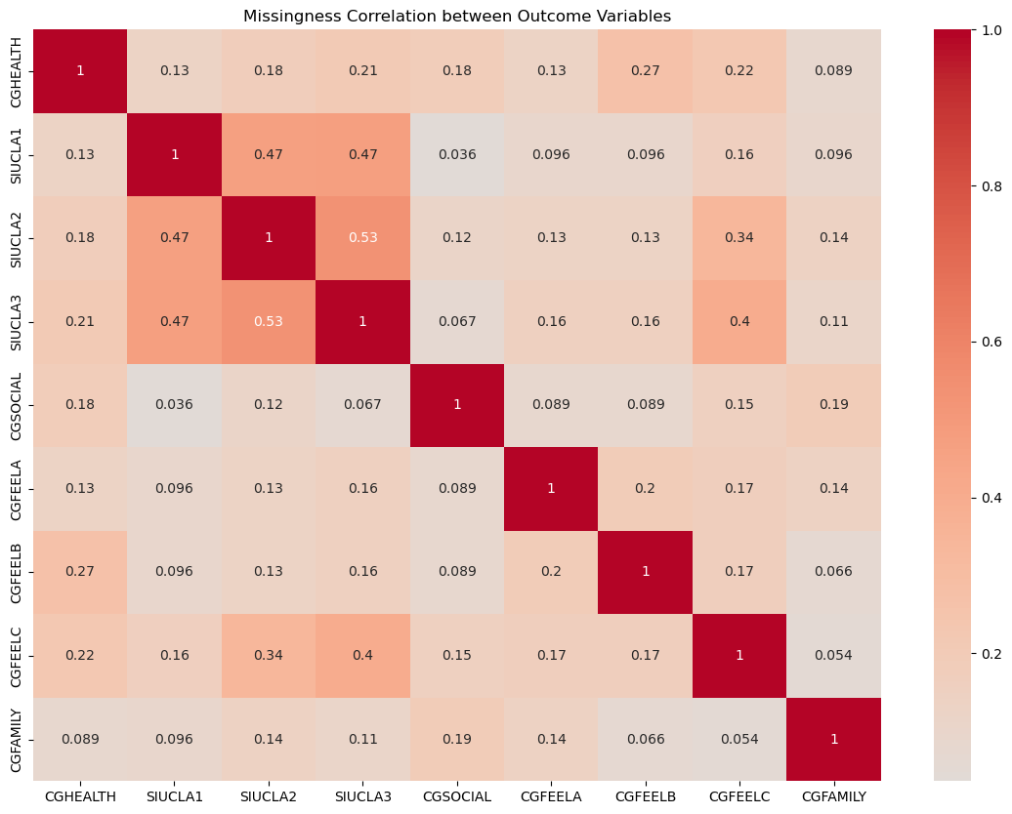

**Figure 1: Missingness correlation heatmap conducted between the outcome variables (subcomponent variables)**

**2.4.2 Composite Variables and Covariate Transformations**

Once the data was cleaned, we began constructing the composite variables for social and emotional health. Physical health did not need to be constructed by any component variables as it was only defined by ‘CGHEALTH’ which was a self-rated question regarding the caregiver’s current general health as compared to one year ago. Each of the remaining covariables, comprised of both ordinal and nominal responses, would be transformed into categorical data type variables and then remapped for the exploratory data analysis. One-hot encoding would then be applied to all nominal variables to be used in regression modeling in an attempt to avoid potential multicollinearity issues.

**2.4.3 Social Health Composition**

The social health variable was defined by the caregiver having a connection to their community, including their family and other social life companions, as well as having feelings of isolation from their social circles. Social health consisted of three component variables those being ’Lonely’, ‘CGFAMILY’, and ‘CGSOCIAL’, with ‘Lonely’ being another composite variable. The ‘Lonely’ variable acted like a boolean variable indicating if the caregiver felt either lonely or not lonely. This was determined from a scoring variable, ‘UCLA_Total’ (see Figure 2.1 in appendix), which was composed of another three added subcomponent variables, ‘SIUCLA1’, ‘SIUCLA2’, and ‘SIUCLA3’. Each of the SIUCLA variables were survey questions about how often caregiving prevents one from having enough time for one’s family, having conflicts with social life, and/or feeling sufficiently supported. The ‘CGFAMILY’ and ‘CGSOCIAL’ were also reverse-coded before being added together to create the ‘Social_Health_Score’ variable.

**2.4.4 Emotional Health Composition**

We also defined emotional health as a constructed composite variable being assessed by questions about feeling sufficiently energized each day, feelings of being calm, and feelings of being depressed over the past 4 weeks. The emotional health variable also consisted of three component variables relating to emotional health status, those being ‘CGFEELA’, ‘CGFEELB’, and ‘CGFEELC’. The ‘CGFEELC’ variable was reverse coded before being added together with ‘CGFEELA’, and ‘CGFEELB’ variables to create the ‘Emotional_Health_Score’.

**2.4.5 Covariates**

Covariates from the combined datasets included caregiver biopsychosocial domains: sex, age group, marital status, education, income level, location inside a metropolitan statistical area, and employment status. We also included biopsychosocial domains of the dementia care recipient: sex, age group, and health status as reported by the caregiver. Also included were some characteristics of the caregiver and dementia care partner relationship such as their relationship to the partner, care situation (proportion of care provided, yes or no for responsibility for care on a 24-hour basis, ability to provide care with the belief the care partner would be better off in a care facility, and the intensity of care provided), care partner gains (level of satisfaction for providing care, joy from being a caregiver, sense of accomplishment from being a caregiver, and a sense of fulfilling duty to care partner).

**2.5 Exploratory Data Analysis (EDA)**

After the completion of the data cleaning and preparation phase, we began a covariate analysis of all variables in the dataset. Starting with the outcome variables, each was examined along with their component variables to understand their distributions (see appendix for Figures 2.2-2.7). From the examination of the social and emotional health scores, we were able to identify cut points in their distributions to assign levels of health status, similar to how the levels of physical health status were arranged. These outcomes were now aligned with the same health status levels ranging from ‘Poor’ to ‘Excellent’. Then we conducted a subsequent distribution analysis for both the nominal and ordinal covariates, allowing us to understand the general status for each variable regardless of race/ethnicity (see appendix for Figures 2.8-2.24). Next, we conducted bivariate analyses on the health outcomes by each race/ethnicity group, which then led to examining correlations and distributions of each outcome by race/ethnicity. From these findings, we also opted to explore the distributions of the covariates by each health outcome, now stratified by each category in the race/ethnicity variable. A correlative analysis with the covariates and the health outcomes was also performed, producing a large heatmap visualization, as seen below, in an attempt to identify any relevant associations between the covariates themselves and the outcomes. We then finally conducted a bivariate analysis of each covariate by each target health outcome, stratifying by the exposure variable. This was done using chi-square contingency testing for nominal covariates and Spearman’s rank correlation testing for ordinal covariates which we deemed useful for identifying statistically significant results (α = 0.05). This also allowed us to determine if the significant covariates were consistent with the model results after regression modeling was complete. Using Spearman’s correlation for the ordinal variables allows us to identify the strength and direction of each covariate and health outcome, thus accounting for the ordered nature of these variables whereas the chi-square testing on the nominal variables will treat the health outcomes responses as their own categories. This was done by looping each covariate and health outcome in a subset data frame of each race/ethnicity group through the chi-square/Spearman's rank tests which outputted the significant covariates into a table. Thus, we were able to identify certain covariates significant in the unique race/ethnic groups.

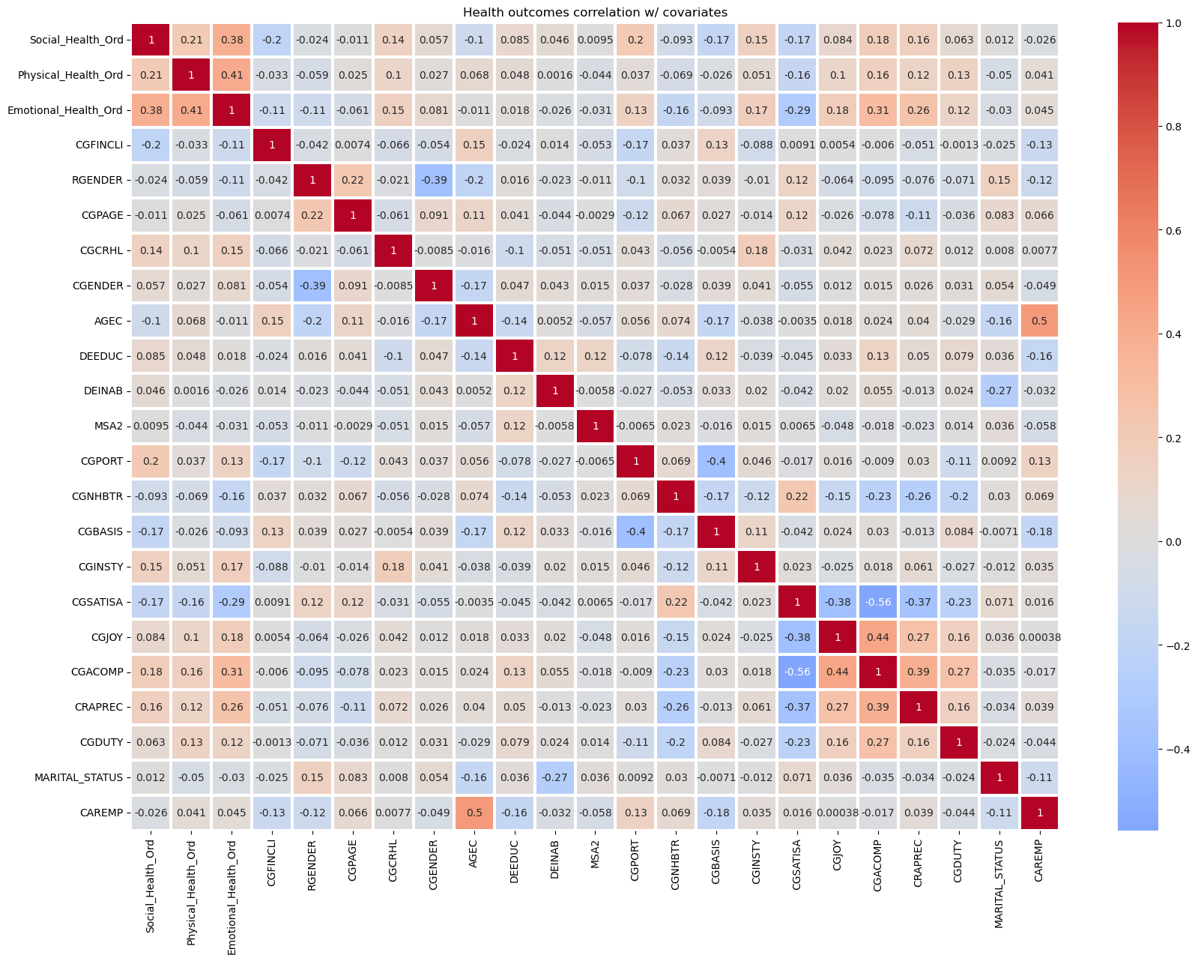

**Figure 2.25: Correlational heatmap displaying the relationships between each covariate and health outcome.**

**2.6 Regression Modeling**

Using racial and ethnic stratification, our goal with the regression modeling phase was to model the variables as predictors for different health outcomes. To concentrate on the variables of interest, a copy of the original dataset was first made, and non-covariate columns were excluded. Because of this preparation, the analysis contained only the exposure variable of race/ethnicity, the one-hot encoding nominal covariates, the ordinal covariates, and the health outcomes. To make the modeling process more straightforward, nominal categorical variables with True/False values from one-hot encoding were then changed to a binary encoding (1/0).

**2.6.1 Health Outcomes and Predictors**

We modeled three different health outcomes: social, physical, and emotional health. All covariates, which were a wide range of socioeconomic, caregiving, and demographic variables, were included as predictors in each model. In order to make sure that the modeling method could handle ordinal variables effectively, the ordinal categorical variables were each composed of five responses, were re-encoded as integer codes with values ranging from 0 to 4. A more sophisticated comprehension of the effects of various levels within these ordinal categories was made possible by this modification.

**2.6.2 Modeling Procedures**

We used a stratifying modeling process for predicting the health outcomes for each race/ethnic group. To include just the observations for the designated race/ethnic group, the dataset was filtered by the four categories of race/ethnicity available. The results from EDA did not indicate any inherent linear relationships with the outcome variables, and because of the categorical nature of the data, we opted to use second-order optimization through logistic regression. Therefore, using the BFGS optimizer, twelve ordered logistic regression models (three models for each race/ethnicity) were fit using the OrderedModel function and parameters from statsmodels. This method offered a concise framework for comprehending how each of our covariate predictors affected the three health outcomes for each racial/ethnic group.

**3. Results**

In order to provide insight into the connections between the variables and health outcomes for each racial or ethnic group, the modeling results were compiled in Table 2.1–2.3 below. Visualizations plotting the distributions and proportions of the significant covariate predictors by each health outcome and race/ethnic group are available in Figures 3.1–3.6 at the end of the results section. The results from the chi-square and Spearman’s rank tests are also available in Table 3.1 and 3.2, respectively. These summaries provided a greater understanding of each covariate’s relationship with each health outcome across our diverse sample of caregivers and emphasized the factors that both differ and are shared between them. By taking a systematic approach to the modeling and independence/associative testing, the results offer a new perspective on the data which could be useful in addressing health disparities among caregivers from various racial and cultural origins.

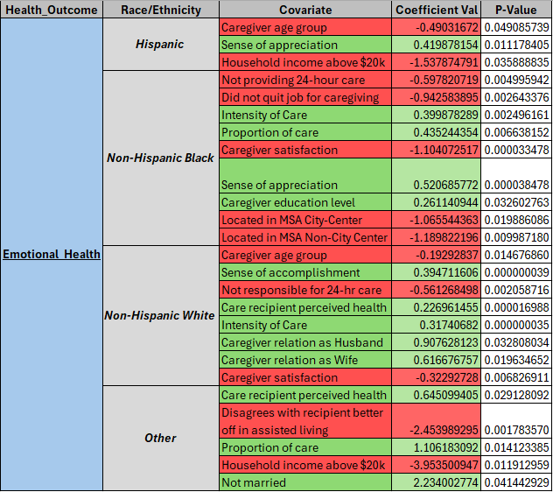

**Table 2.1: Significant Predictors from Emotional Health Model stratified by Race/Ethnicity**

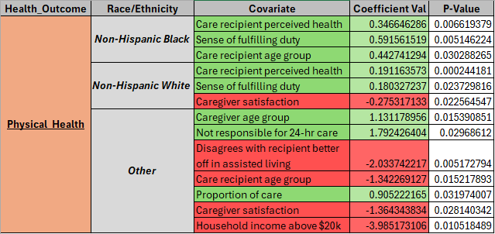

**Table 2.2: Significant Predictors from Physical Health Model Stratified by Race/Ethnicity**

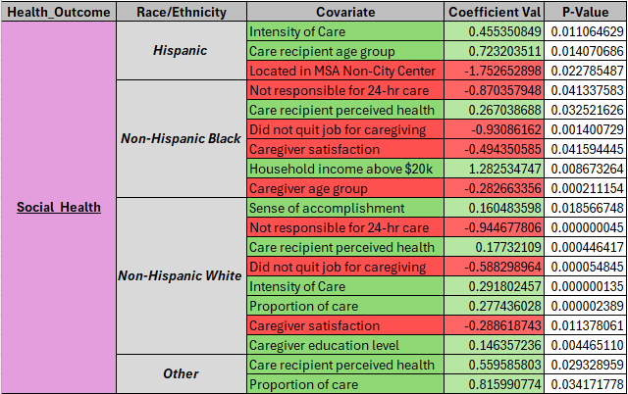

**Table 2.3: Significant Predictors from Social Health Model stratified by Race/Ethnicity**

**3.1 Chi-Square and Spearman’s Rank Results**

Given that there's a large number of covariates being tested in these different methods, we assume that by focusing on just the statistically significant results (p < 0.05), we're able to better comprehend the risks from relationships that could have happened by chance. The chi-square and Spearman’s rank results have provided a better in-depth perspective on associative factors, especially for each race group. From the chi-square testing, it appears non-Hispanic whites have the most amount of association between the nominal covariates and each health outcome, followed by non-Hispanic black caregivers, then Hispanic and non-Hispanic other caregivers respectively. On the other hand from Spearman’s rank testing, non-Hispanic black caregivers had more ordinal covariates displaying significant correlation with each outcome. This is then followed by non-Hispanic white caregivers, Hispanic caregivers, and then subsequently, non-Hispanic other caregivers who totaled only one significant relationship. Below are tables 2.2 and 2.3 displaying the concatenated results of the chi-square results and Spearman’s rank correlation values.

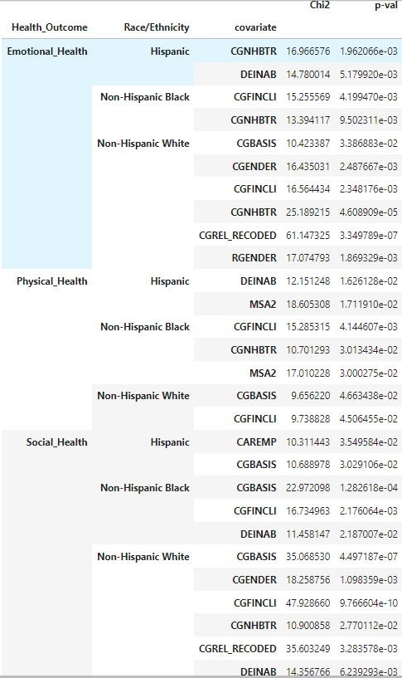

**Table 3.1 Significant Covariates from Chi-Square Testing for each Health Outcome and Race/Ethnicity**

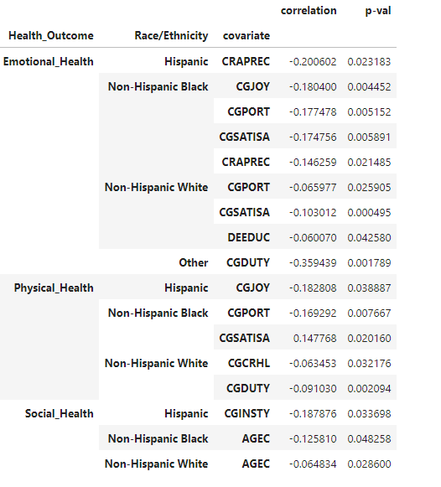

**Table 3.2 Significant Covariates from Spearman’s Rank Testing for each Health Outcome and Race/Ethnicity**

**3.2 Summary of Key Findings on Emotional Health**

* **Chi-Square Results**

Non-Hispanic White caregivers again showed the most significant associations with six covariates. These were: their current employment status due to caregiving-related changes, the caregiver's sex, the care recipient's sex, the caregiver's relationship to the care partner, whether or not the caregiver felt the care recipient would be better off in an assisted living facility, and if the caregiver is responsible for providing care on a 24-hour basis. For the minority caregiver groups, non-Hispanic Black and Hispanic caregiver groups each had two significant nominal covariates. One of these covariates shared significance for both groups, which was the caregiver's response to whether their recipient would be better off in some sort of assisted living facility.

* **Spearman’s Rank Results**

We found that in the Spearman’s rank correlation testing, there were a lot more significant covariates as compared to the results from social and physical health. In non-Hispanic White caregivers, we observed three significant associations of caregiver education level, caregiver portion of care, and satisfaction gained from providing care. We also noted four significant covariates for non-Hispanic Black caregivers which were caregiver joy from providing care, how often the caregiver thinks they are appreciated, the proportion of care provided, and finally the satisfaction from providing care. Hispanic and non-Hispanic other caregivers each had one significant covariate, those being how often they think they were appreciated and how often they feel they’re fulfilling their duty to the recipient, respectively.

* **Modeling**

The modeling for emotional health revealed the most amount of significant predictors compared to the remaining health outcome models with a total of 25 significant covariate predictors. Beginning with Hispanic caregivers, we observed that caregivers’ emotional health was adversely impacted by being in an older age group and having an annual household income above $20,000, while the caregiver feeling appreciated by the care recipient had a favorable effect. For non-Hispanic White caregivers, we noted that being a spouse (either husband or wife, as both were significant), providing a higher intensity level of care to the care recipient, feeling a sense of accomplishment from caregiving, and having a better perceived health of the care recipient had positive effects on their emotional health. Conversely, we noted that higher levels of caregiving satisfaction, not being responsible for providing 24-hour care to their recipient, and the caregiver's age group were negatively affecting their emotional well-being. Next, we found that non-Hispanic Black caregivers' emotional health seemed to be unfavorably impacted by living in either a city center or a non-city-center metropolitan area, not having to quit their jobs due to caregiving-related functions, a sense of fulfilling their duty to their partner, higher satisfaction levels from caregiving. On the other hand, a sense of feeling appreciated, providing higher intensity of care, providing higher proportions of care, and attainment of higher education were associated with better emotional health. The last model in this series was for other non-Hispanic caregivers. We found that their emotional health was negatively affected by having an annual household income above $20,000 and disagreement about whether their care partner would be better off in assisted living. Though providing a higher proportion of care, better perception of the care recipient's health, and not being married interestingly had a supportive effect on their emotional health.

**3.3 Summary of Key Findings on Physical Health**

* **Chi-Square Results**

In the results of chi-square testing covariates with physical health, non-Hispanic black caregivers displayed the most amount of significant associations with a total of three with those being their urban/rural location, whether they felt their care partner would be better off in an assisted living facility, and their current employment status due to caregiving-related changes. Among non-Hispanic white caregivers, their current employment status due to caregiving-related changes and whether or not they provided 24-hour care was found to be significant. The significant covariates for Hispanic caregivers were their urban or rural location and their annual household income being above or below $20,000 while no significant results were found for Non-Hispanic Other caregivers.

* **Spearman’s Rank Results**

There were overall very few significant correlations observed between the ordinal covariates and physical health between the race/ethnic groups, with all correlation values being negative except for one. For non-Hispanic White caregivers, the only significant correlations we noticed were the care recipient's health rating from the caregiver and how often the caregiver feels they are fulfilling their duty by caring for the recipient. An equal amount of significant observations were seen in non-Hispanic Black caregivers, however, these significant correlations were different than in non-Hispanic White caregivers. We found that with the proportion of care provided by the caregiver and the satisfaction gained from performing care tasks. Lastly for Hispanic caregivers, we observed only one significant covariate, which was how often caregiving gives the caregiver joy. Again there were no significant correlations were seen for non-Hispanic other caregivers.

* **Modeling Results** In modeling physical health and stratifying by each race/ethnic group, we observed the least amount of significant predictors with only 13 total, three each for non-Hispanic White and Black caregivers and seven for non-Hispanic other caregivers. Something we found interesting is that there were no significant covariate predictors for Hispanic caregivers. Then beginning with non-Hispanic White caregivers, we found that physical health was positively associated with their perceived general health of the care recipient and a sense of fulfilling their duty to the care recipient. The only negative association we discovered was satisfaction levels from caregiving unfavorably affected general physical health in some way. All significant covariates for non-Hispanic Black caregivers' had a beneficial impact on physical health. These include a sense of fulfilling their duty to their care partner, their perceived general health of the care recipient, and the care recipient's age group. Finally, for other non-Hispanic caregivers, we observed that not being responsible for 24-hour care, the caregiver's age group, and the proportion of care provided had a positive impact on physical health. Conversely, the predictors of disagreement on whether the care recipient would be better off in assisted living, having an annual household income above $20,000, the care recipient's age, and satisfaction from providing caregiving services adversely impacted physical health.

**3.4** **Summary of Key Findings on Social Health**

* **Chi-Square Results**

As with the other health outcomes, Non-Hispanic White caregivers showed the most significant associations. These significant covariates are caregiver employment status, caregiver sex, caregiver household income either above or below $20,000, caregiver opinion on whether the recipient would be better off in an assisted living facility, and whether or not they provided 24-hour care. non-Hispanic Black caregivers displayed a few significant independent relationships with caregiver household income, whether or not they provide 24-hour care, and if they had to quit their job to provide care to the recipient. The only two significant covariates for Hispanic caregivers were their employment status, and again, whether or not they provide 24-hour care. For all three groups, minus ‘other’ caregivers, the 24-hour care covariate remained consistently independently significant from social health.

* **Spearman’s Rank Results**

Spearman’s rank testing for social health did not yield as many significant results as the other tests. We observed only three significant correlations in total, one for each race/ethnicity group, with the exception of non-Hispanic other caregivers. For both non-Hispanic White and Black caregivers, the caregiver’s age group was the only significant correlative ordinal covariate while for Hispanic caregivers, intensity of care provided was the one significant correlation.

* **Modeling Results**

The last set of models constructed for social health revealed 19 significant covariate predictors with a few being consistent across the racial/ethnic groups that were modeled. Starting with Hispanic caregivers, social health was seemingly affected contrarily by living in a non-city center metropolitan area, while the seemingly two positively influential factors were the age group of the care recipient and the higher intensity of care provided. We found that non-Hispanic White caregivers were impacted beneficially by the perceived general health of the care recipient, their highest attained education level, providing a higher proportion of care, providing higher intensity of care, and a feeling of a sense of accomplishment for caregiving. The negative impacts on social health appeared to arise from their satisfaction levels from caregiving, the caregiver's age group, not quitting their job due to caregiving, and not being responsible for providing 24-hour care. Next in Hispanic Black caregivers, it seems that having an annual household income over $20,000 and the perceived health of the care recipient positively influenced their social health. Though contrarily, not quitting their job due to caregiving, not being responsible for providing 24-hour care, and lower satisfaction levels from caregiving showed adverse associations. Finally, the two positive impacts on social health for other non-Hispanic caregivers were the proportion of care provided and the perceived general health status of the care recipient.

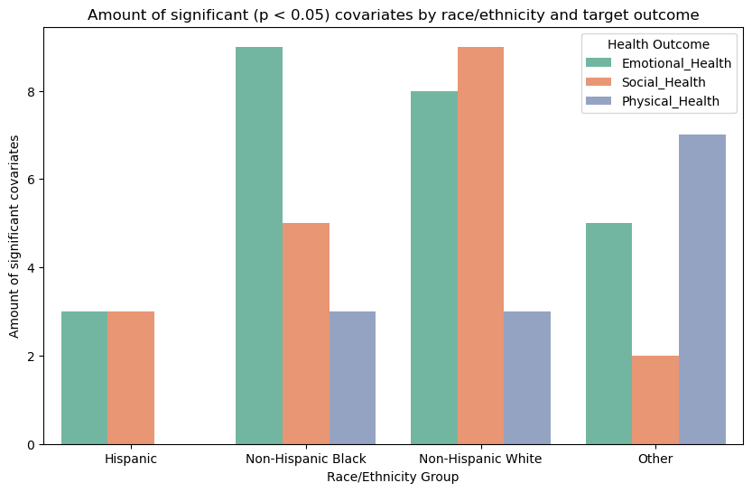

**Figure 3.1: Graphing the number of significant covariate predictors by race/ethnicity for each target health outcome.**

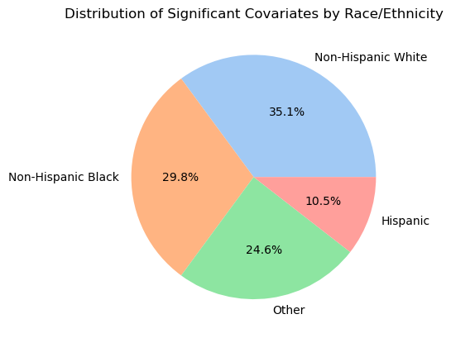

**Figure 3.2: Plotting the distribution of all significant covariates from modeling by race/ethnicity.**

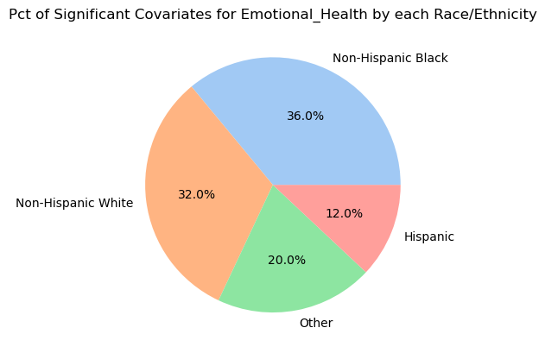

**Figure 3.3: Plotting the distribution of significant covariates from the Emotional Health models by each race/ethnicity.**

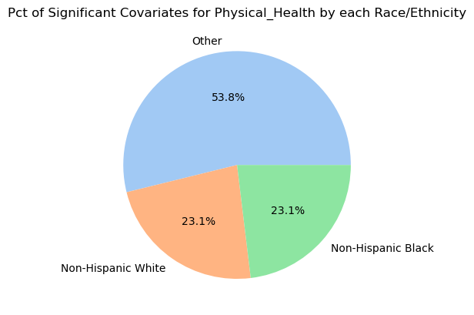

**Figure 3.4: Plotting the distribution of significant covariates from the Physical Health models by each race/ethnicity.**

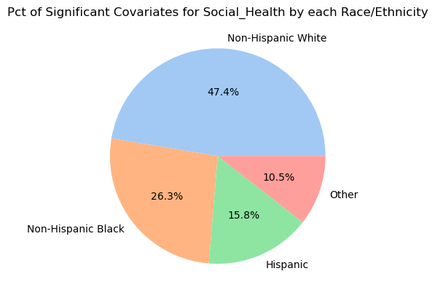

**Figure 3.5: Plotting the distribution of significant covariates from the Social Health models by each race/ethnicity.**

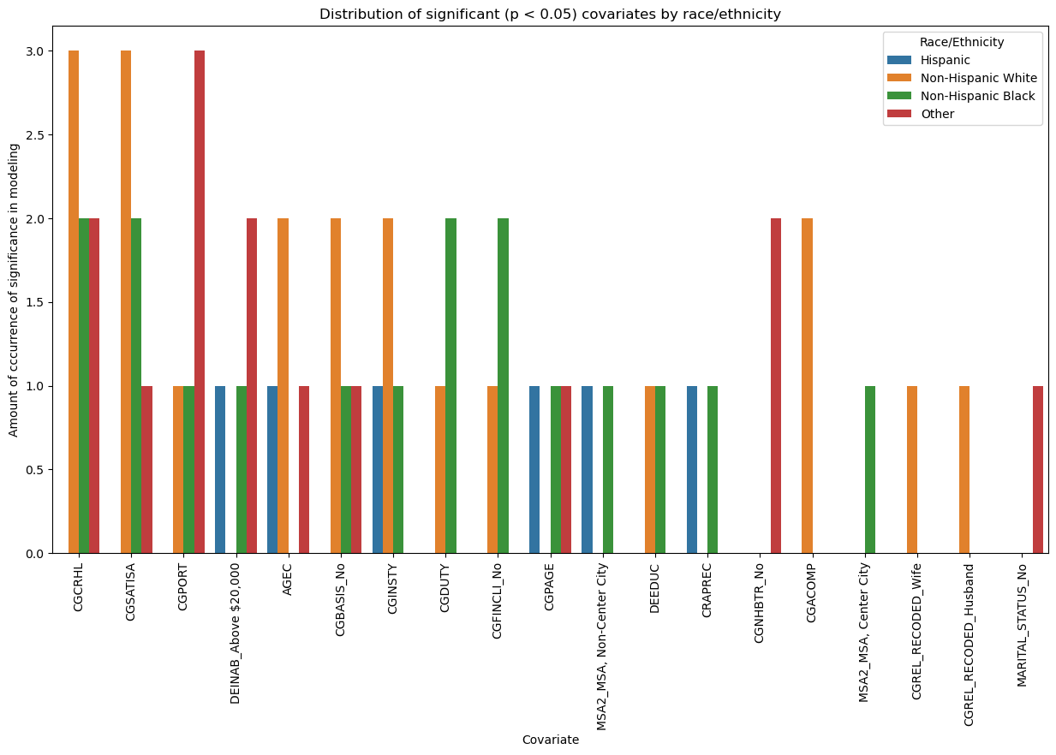

**Figure 3.6: Graphing the distribution of each covariate occurrence in each health outcome model by race/ethnicity.**

**4. Discussion**

Overall, accounting for the significant covariates in the modeling, the chi-square testing, and Spearman’s rank correlation testing, it would appear that non-Hispanic white caregivers appear to be the most affected in terms of their combined health outcomes. However, since this study aims to examine the differences between non-Hispanic White caregivers and the remaining groups, we can veritably conclude that the most afflicted group among the remaining races/ethnicities, compared to non-Hispanic White caregivers, is non-Hispanic Black caregivers. From the results and insights from visualizing significant covariates, we see that they display a comparable amount of significant predictors, having both positive and negative impacts across the emotional, physical, and social health models. Therefore indicating diverse and complex experiences in caregiving compared to non-Hispanic White caregivers. From these results, we can gather that non-Hispanic Black caregivers likely face greater significant challenges due to complex influence from caregiving intensity, caregiving satisfaction levels, a sense of fulfilling their duty to their care recipient, and a sense of appreciation from their care recipient. Hispanic caregivers likely follow non-Hispanic blacks in their affliction due to challenges we’ve seen relating to their age and their income status, as well as social health challenges due to their location and likely their care intensity provided to their recipients. Non-Hispanic other caregivers appear to have the least amount of significant covariates, though this does not nullify the fact they still may be substantially afflicted by their perceptions about assisted living for their care recipient, income levels, and their responsibilities to provide care over a 24-hour basis.

This research should indicate the notion that dementia caregiver disparities are not nonexistent and imply that for the different health outcomes of interest, we were able to identify several unique indicators for each group in our study. Planning interventions for improving health outcomes for each group should be thoughtfully considered because of this. Social health and emotional health seem to be the most relevant to thoughtful plans for intervention due to the combined amount of observations we gathered from the results. In emotional health, interventions could focus on enhancing the caregiver's sense of appreciation through recognition programs and caregiver support groups. Since we also observed financial status as a factor in the minority groups, perhaps planning for financial assistance might help those in higher income brackets who still struggle emotionally. Creating support for spousal caregivers might also prove beneficial for these minority groups along with providing these caregivers with a better sense of psychological help to confront what we perceive as somewhat of a paradox in caregiver satisfaction levels leading to adverse emotional health outcomes. We might also hope there’s the opportunity to create social support programs in urban/suburban centers to assist in recognizing minority caregivers for their intense efforts, which would hopefully assist their social health outcomes. Though if not anything else, maybe providing these caregivers with open educational opportunities and programs to help balance their satisfaction and potential stress when caregiving might also improve their social health.

**5. Conclusion**  
 This study highlights significant disparities in the health outcomes of caregivers of individuals with dementia based on their race and ethnicity, emphasizing the critical need for culturally sensitive interventions. Strictly by numbers, from significant factors across all evaluations conducted, we count 32 influentially related factors for non-Hispanic Black caregivers, 41 for non-Hispanic White caregivers, 15 for Hispanic, and 14 for other non-Hispanic other caregivers totaling 102 observations of significant covariate influencers. Compared to non-Hispanic caregivers, non-Hispanic Black caregivers may be the most affected by dementia caregiving disparities. Though the model evaluation seems in and of itself, quite poor, it’s possible that the intricate combination of covariates caused these particular results. This thorough analysis of the National Survey of Older Americans Act Participants (NSOAAP) emphasizes the need for initiating a deeper understanding of these drivers in the health outcomes of diverse caregivers. Thus, we may be able to bring new solutions to the forefront of this problem to help eliminate factors contributing to these disparities among dementia caregivers.

**References**

1. Alzheimer’s disease facts and figures. Alzheimer’s Disease and Dementia. (2024). <https://www.alz.org/alzheimers-dementia/facts-figures>.
2. Lin, C. Y., Shih, P. Y., & Ku, L. E. (2019). Activities of daily living function and neuropsychiatric symptoms of people with dementia and caregiver burden: The mediating role of caregiving hours. Archives of gerontology and geriatrics, 81, 25–30. <https://doi.org/10.1016/j.archger.2018.11.009>.
3. Schulz, R., & Sherwood, P. R. (2008). Physical and mental health effects of family caregiving. The American journal of nursing, 108(9 Suppl), 23–27. <https://doi.org/10.1097/01.NAJ.0000336406.45248.4c>
4. Podgorski CA, Anderson SD, Parmar J. A Biopsychosocial-Ecological Framework for Family-Framed Dementia Care. Frontiers in psychiatry. 2021;12:744806. doi:10.3389/fpsyt.2021.744806
5. National survey of older americans act participants (NSOAAP). CMS.gov. (2024). https://www.cms.gov/about-cms/agency-information/omh/resource-center/hcps-and-researchers/data-tools/sgm-clearinghouse/nsoaap
6. Missing at random. Missing At Random - an overview | ScienceDirect Topics. (n.d.). https://www.sciencedirect.com/topics/mathematics/missing-at-random#:~:text=The%20assumption%20of%20Missing%20at,value%20of%20the%20variable%20itself

**Appendix**

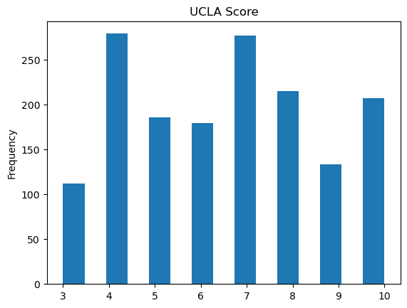

**Figure 2.1: Distribution of UCLA Score variable (continuous)**

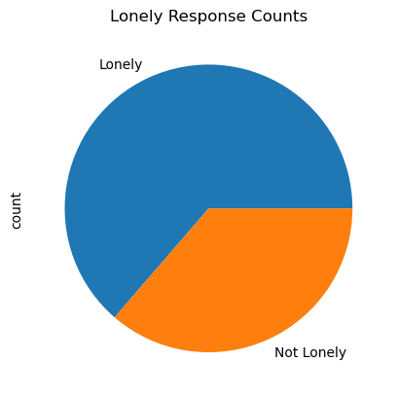

**Figure 2.2: Distribution of Lonely/Not Lonely variable (nominal)**

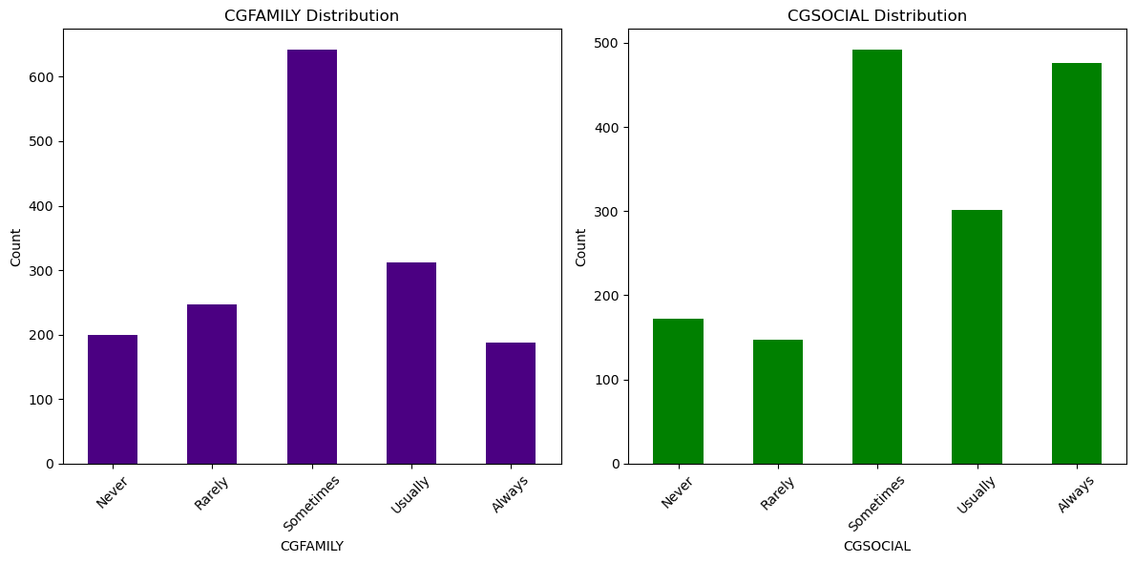

**Figure 2.3: Distribution of CGFAMILY and CGSOCIAL component variables (ordinal)**

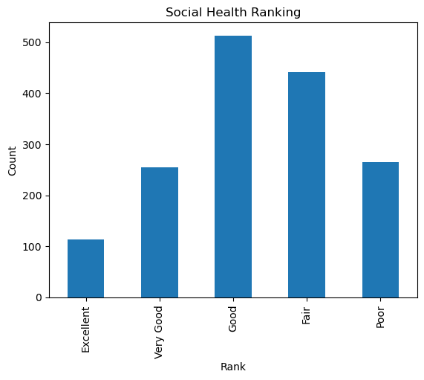

**Figure 2.4: Distribution of Social_Health outcome variable (ordinal)**

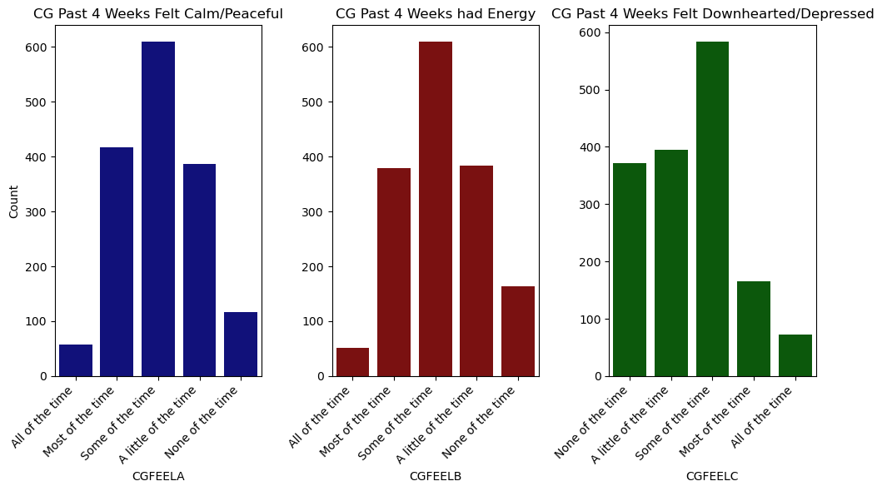

**Figure 2.5: Distribution of CGFEELA/B/C component variables (ordinal)**

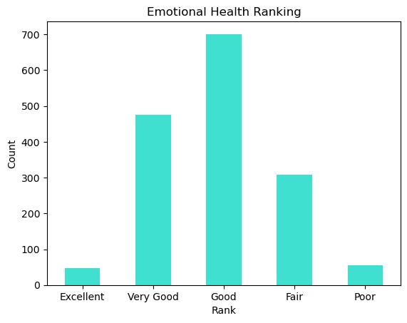

**Figure 2.6: Distribution of Emotional_Health outcome variable (ordinal)**

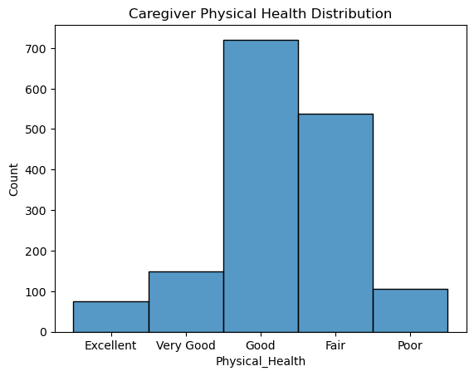

**Figure 2.7: Distribution of Physical_Health outcome variable (ordinal)**

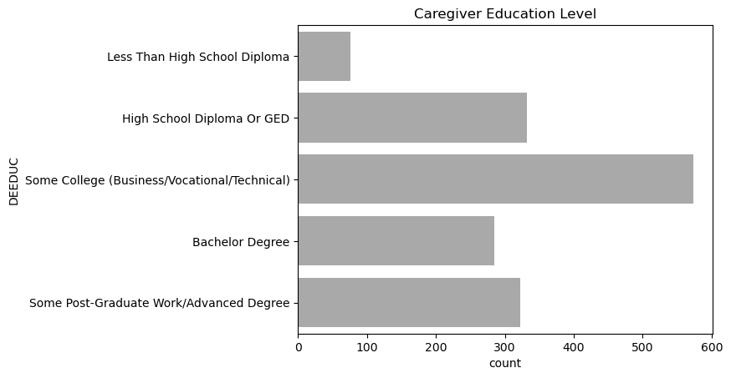

**Figure 2.8: Distribution of DEEDUC covariate (ordinal)**

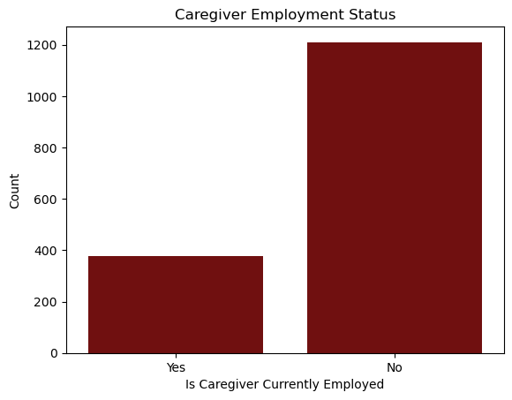

**Figure 2.9: Distribution of CAREMP covariate (nominal)**

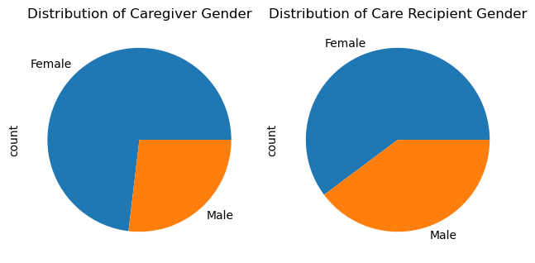

**Figure 2.10: Distributions of CGENDER and RGENDER covariates, respectively (nominal)**

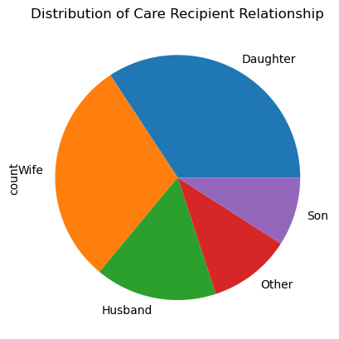

**Figure 2.11: Distribution of CGREL_RECODED covariate (nominal)**

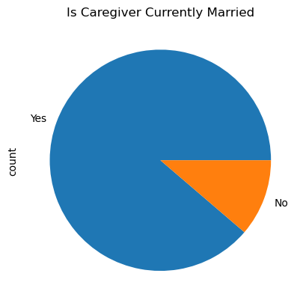

**Figure 2.12: Distribution of CAREMP covariate (nominal)**

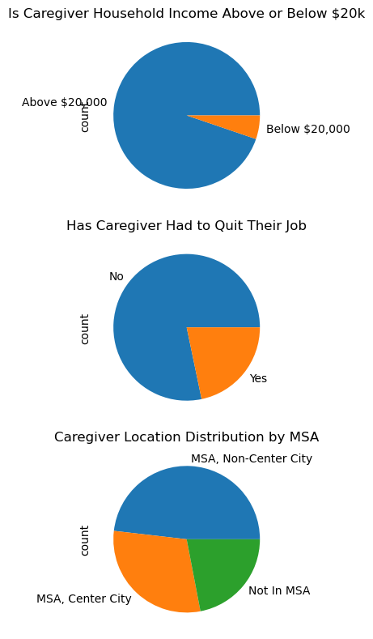

**Figure 2.13: Distribution of DEINAB, CGFINCLI, and MSA2 covariates, respectively (nominal)**

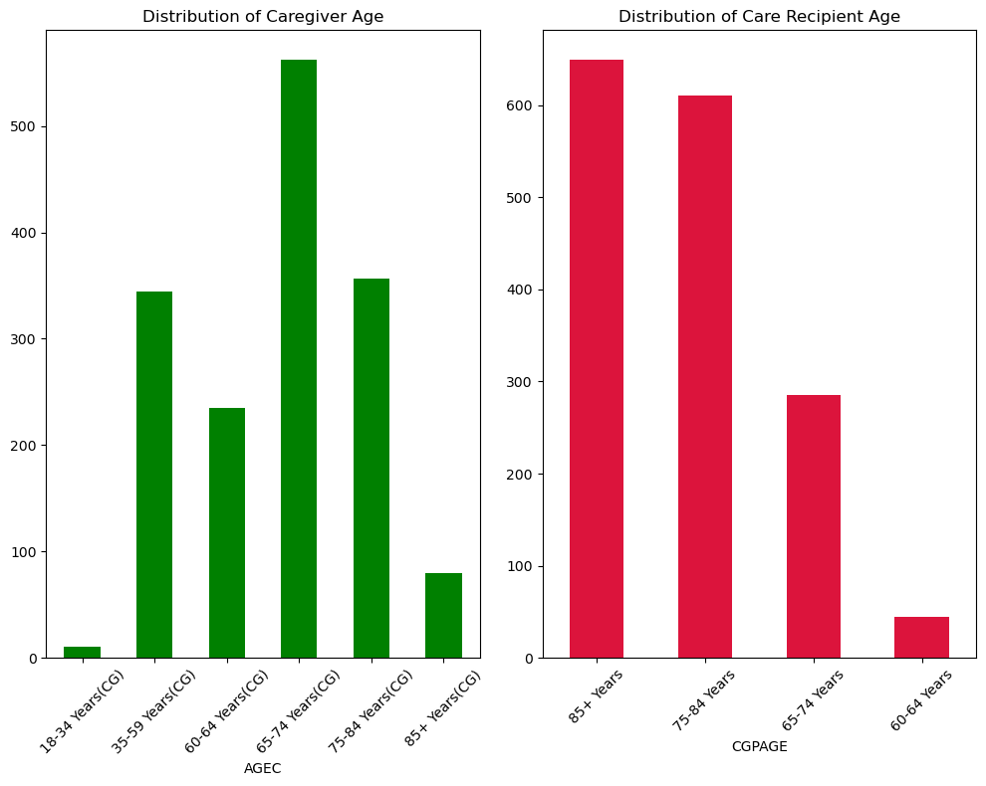

**Figure 2.14: Distribution of AGEC and CGPAGE covariates, respectively with 5-level distribution (ordinal)**

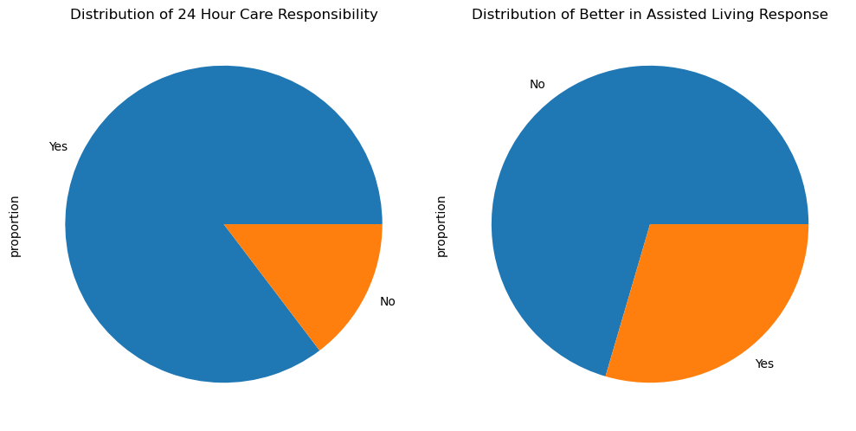

**Figure 2.15: Distribution of CGBASIS and CGNHBTR covariates, respectively (nominal)**

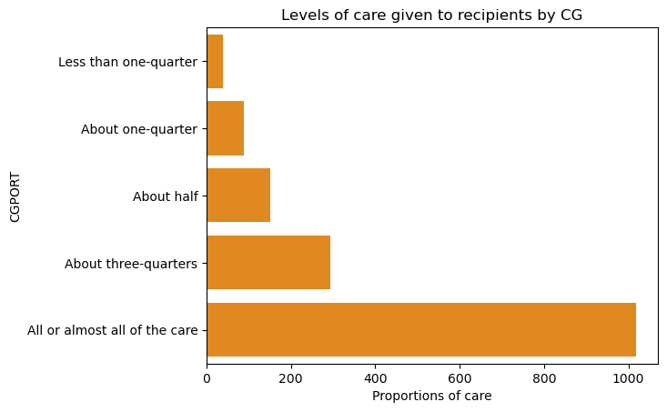

**Figure 2.16: Distribution of CGPORT covariate with 5-level distribution (ordinal)**

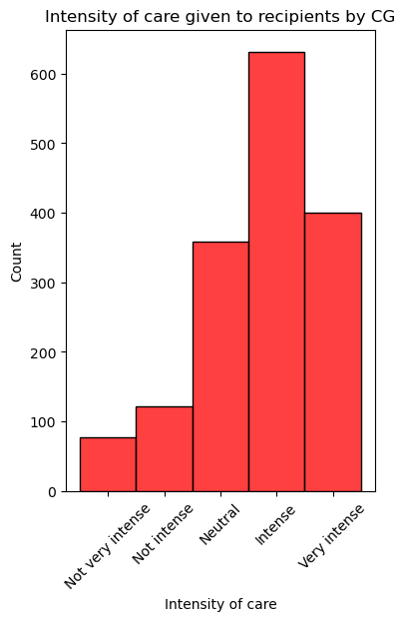

**Figure 2.17: Distribution of CGINSTYcovariate with 5-level distribution (ordinal)**

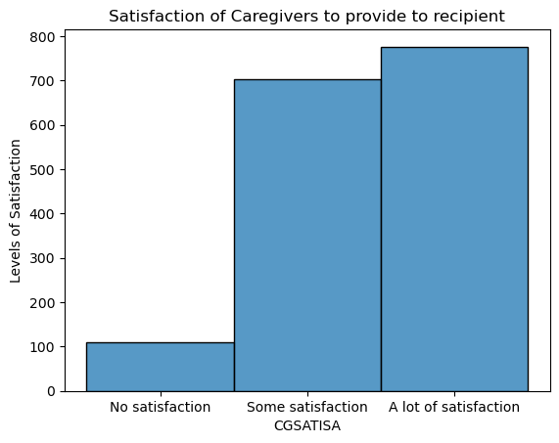

**Figure 2.18: Distribution of CGSATISA covariate with 3-level distribution (ordinal)**

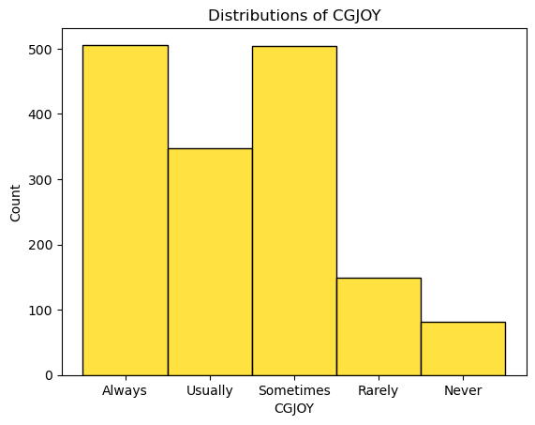

**Figure 2.19: Distribution of CGJOY covariate with 5-level distribution (ordinal)**

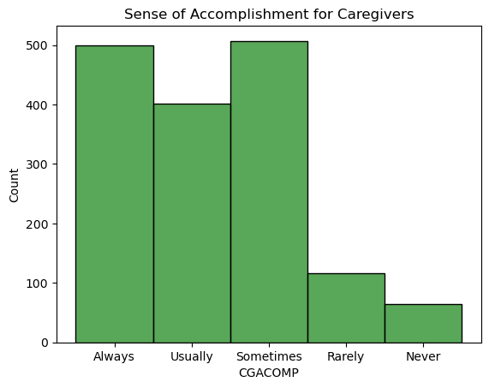

**Figure 2.20: Distribution of CGACOMP covariate with 5-level distribution (ordinal)**

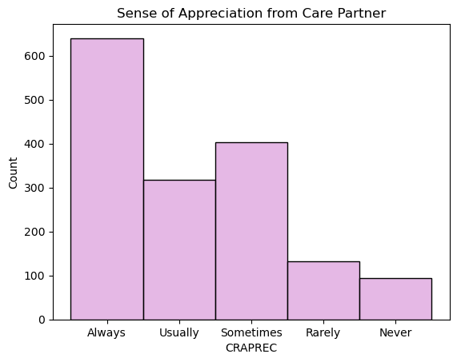

**Figure 2.21: Distribution of CRAPREC covariate with 5-level distribution (ordinal)**

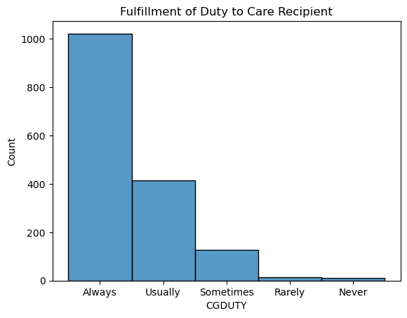

**Figure 2.22: Distribution of CGDUTY covariate with 5-level distribution (ordinal)**

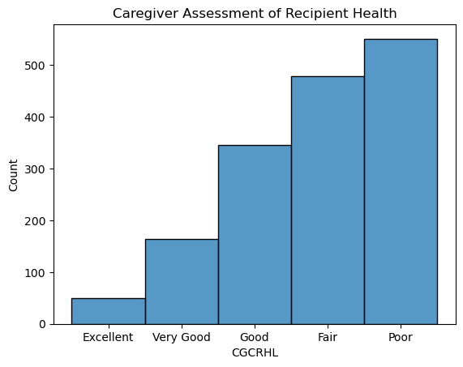

**Figure 2.23: Distribution of CGCHRL covariate with 5-level distribution (ordinal)**

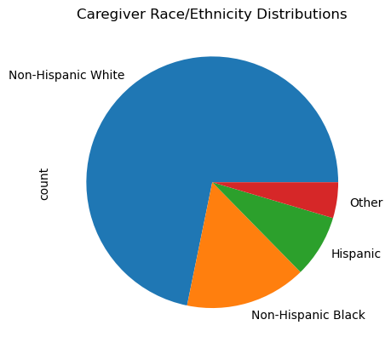

**Figure 2.24: Distribution of RACE_ETHNICTY4CAT exposure variable (nominal)**